**CS 255 Business Requirements Document Template**

**Complete this template by replacing the bracketed text with the relevant information.**

This template lays out all the different sections that you need to complete for Project One. Each section has guiding questions to prompt your thinking. These questions are meant to guide your initial responses to each area. You are encouraged to go beyond these questions using what you have learned in your readings. You will need to continually reference the interview transcript as you work to make sure that you are addressing your client’s needs. There is no required length for the final document. Instead, the goal is to complete each section based on your client’s needs.

**Tip:** You should respond in a bulleted list for each section. This will make your thoughts easier to reference when you move into the design phase for Project Two. One starter bullet has been provided for you in each section, but you will need to add more.

**System Components and Design**

**Purpose**

***What is the purpose of this project? Who is the client and what do they want their system to be able to do?***

The purpose this project is to provide the guidance to the driving student and aides on the market to assist drivers in passing the driving test successfully. The main goal of this project is to create a system (website or application) and give training and practice to the new students who want to pass the driving test.

* The client is the DriverPass he wants the system should have such functionalities  
  Get the information from the student
* From where we will pick and drop him
* Set and cancel appointments by clients
* It should be able to schedule on the road training as well.
* It should have three packages which are depends on num of hours and price
* Track the system (User/admin changes will be tracked)
* It should maintain the security
* It should be in touch with DMV

**System Background**

***What does DriverPass want the system to do? What is the problem they want to fix? What are the different components needed for this system?***

DriverPass wants a system that provides training to new students who want to pass the driver test. They want this system to help Driverpass access their data both from and where and also have the option to download and work offline. Providing this system will help new students pass their driver test at the DMV.

* Students Information and data access
* Security features
* Tracking on reservation , modification and cancelation
* Driver with specific car information
* Provide online exams and individual classes
* Different Pricing Package as the student need
* Schedule actual driving training on the road.

**Objectives and Goals**

What should this system be able to do when it is completed? What measurable tasks need to be included in the system design to achieve this?

At the end when this system is completely developed then system will be able to completely train the students for to pass the driving test. The system will allow customers to practice, schedule, change, and cancel on the road training. There should be complete flow diagram of the system how the system will work i-e activity diagram and class diagram that is needed for the develop the  
system.

**Requirements**

**Nonfunctional Requirements**

In this section, you will detail the different nonfunctional requirements for the DriverPass system. You will need to think about the different things that the system needs to function properly.

**Performance Requirements**

***What environments (web-based, application, etc.) does this system need to run in? How fast should the system run? How often should the system be updated?***

I think there should a web app for this system and that should be developed in best  
framework or library and during the development performance of the system should be regularly  
monitored. System should be update as the requirement change.

**Platform Constraints**

***What platforms (Windows, Unix, etc.) should the system run on? Does the back end require any tools, such as a database, to support this application?***

I think System should not be platforms dependent it should be independent as we are  
recommending the web app so it could be open in any of the platform. As the client want, we can  
use AWS service for handling the backend and the security of the system. Yes, we will need a  
database to store all the records.

**Accuracy and Precision**

***How will you distinguish between different users? Is the input case-sensitive? When should the system inform the admin of a problem?***

Yeah, it’s easy to distinguish the different user of the system we will assign them different  
roles like (Admin, Driver, Student etc.) on the bases of these roles we can distinguish the different  
user. When someone try to break the security or anything bad happened in the system then system  
should inform the Admin

**Adaptability**

Can you make changes to the user (add/remove/modify) without changing code? How will the system adapt to platform updates? What type of access does the IT admin need?

Yes, we can make changes to the user without changing the code we will provides all the  
functionalities from the starting that admin can add update and delete the user. If the updates come,  
we will develop such a system that can update easily like it will be converted to components. Its  
admin just needs to see the system is working properly and is any functionality left or not.

**Security**

***What is required for the user to log in? How can you secure the connection or the data exchange between the client and the server? What should happen to the account if there is a “brute force” hacking attempt? What happens if the user forgets their password?***

As I mentioned we are going to use AWS so we will use AWS User handler system it will  
solve all of security problems. It provides all the build in functionalities. If the user forget the  
password then we will give him a chance to create a new password by authenticating him by phone  
or email address.

**Functional Requirements**

Using the information from the scenario, think about the different functions the system needs to provide. Each of your bullets should start with “The system shall . . .” For example, one functional requirement might be, “The system shall validate user credentials when logging in.”

* The system shall validate user credentials when logging in.
* The system shall update delete and create a new user.
* The system shall update or delete a package.
* The system shall keep track of user who made changes.
* The system shall notify the admin if anything bad happened

**User Interface**

***What are the needs of the interface? Who are the different users for this interface? What will each user need to be able to do through the interface? How will the user interact with the interface (mobile, browser, etc.)?***

Driver, Student and the admin are three different user those will interact the system  
interface. For each user there will be different interface like admin will be able to manage the  
whole system but driver and student will not have all the functionalities. As we are going to  
make a web app so all the user interact with the system through the browser.

**Assumptions**

***What things were not specifically addressed in your design above? What assumptions are you making in your design about the users or the technology they have?***

As I think everything is going in its perfect way and I have no assumption about the  
technologies right now

**Limitations**

***Any system you build will naturally have limitations. What limitations do you see in your system design? What limitations do you have as far as resources, time, budget, or technology?***

As I think every system that we build have some limitations like budget and time. In this  
system we have time limitation we have not a lot of time so we should complete it in specific time  
period.

**Gantt Chart**

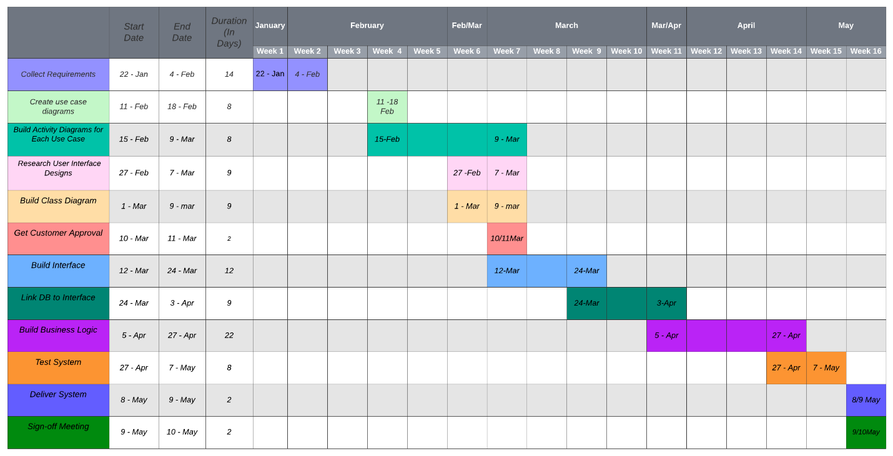Please include a screenshot of the GANTT chart that you created with Lucid chart. Be sure to check that it meets the plan described by the characters in the interview.